**UE21C351A - DATABASE MANAGEMENT SYSTEMS**

**PROJECT REPORT**

**Online Gaming Database----GAMZEE**

**Git-hub repo link :-**

[**https://github.com/ShreyasM8G/Mini-Projects**](https://github.com/ShreyasM8G/Mini-Projects)

**What our project is about:**

An online gaming website where players can play exciting online games, organize tournaments by forming teams and participating in matches. They can even play competitively to top the leaderboard and in tournament games, winner teams can grab prize money and have fun. Therefore, our UI can be used by various gaming platforms to organize the gaming efficiently as it keeps record of the tournaments being organized, matches being played and players taking participation in it. This UI has centralized admin operational management system in order to hold the privileges of adding games, registering teams, scheduling matches, organizing tournaments and adding developers only by admin and hence maintaining data integrity.

**Entity Relationship (ER) Diagram:**

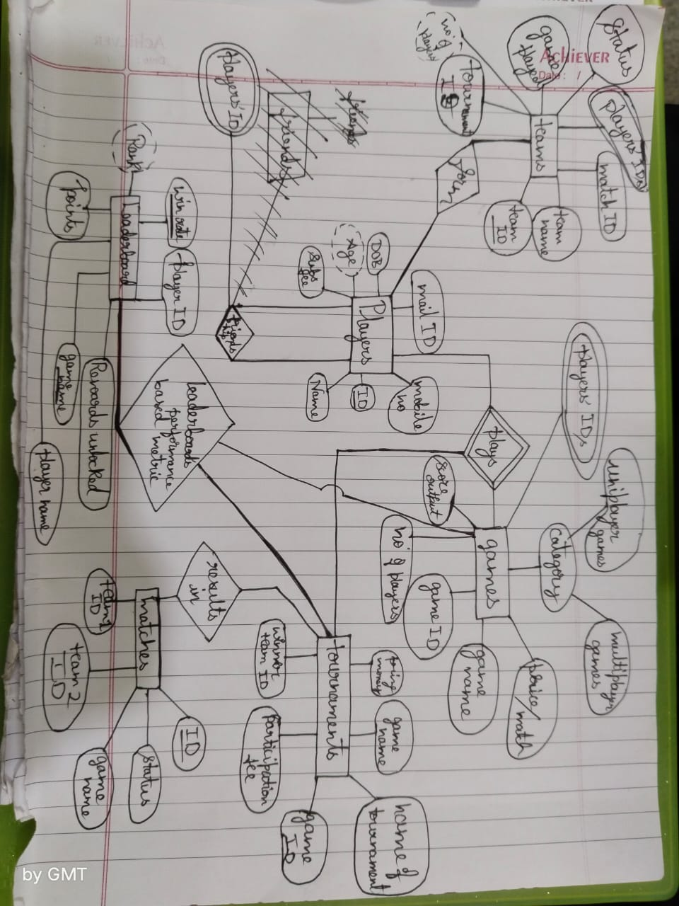

**Relational Schema:**

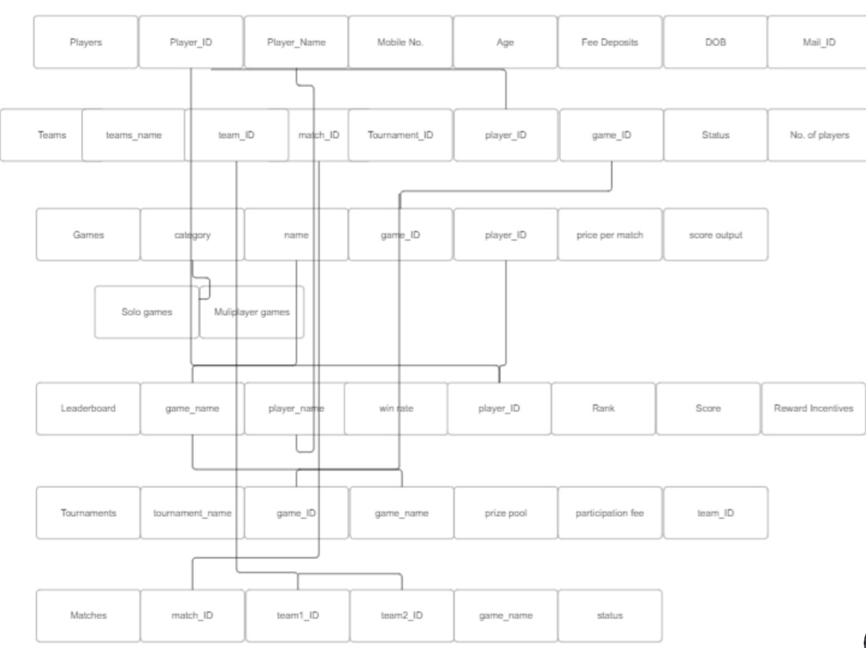

sssssss

**Data Definition Language (DDL) Commands:**

|  |
| --- |
| CREATE TABLE player (  player_id INT auto_increment PRIMARY KEY,  mail_id VARCHAR(255),  dob VARCHAR(50),  age INT, deposits INT, mobile BIGINT(10),  naame VARCHAR(50) );  CREATE TABLE developer (  dev_id INT auto_increment primary key,  dev_name VARCHAR(40),   mail_id VARCHAR(100),  mobile_no BIGINT(10),  game_name VARCHAR(200) );  CREATE TABLE game (  game_id INT auto_increment PRIMARY KEY,   game_name VARCHAR(200),   ppm INT NOT NULL,   category VARCHAR(30),   no_of_players INT NOT NULL,  dev_id INT NOT NULL,  foreign key (dev_id) references developer(dev_id) );  CREATE TABLE tournament(  tourn_id INT auto_increment PRIMARY KEY,  game_id INT,   tourn_name VARCHAR(100),   game_name VARCHAR(200),   Entry_fee INT NOT NULL,   wint_id INT NULL ,  prize INT NOT NULL,  foreign key (game_id) references game(game_id) );  CREATE TABLE team (  team_id INT auto_increment PRIMARY KEY,  tourn_id INT,  team_name VARCHAR(200),  game_name VARCHAR(200),  foreign key (tourn_id) references tournament(tourn_id) ); CREATE TABLE team_player (  player_id INT,  team_id INT,  PRIMARY KEY (player_id, team_id) );  CREATE TABLE matches (  match_id INT auto_increment PRIMARY KEY,   wint_id INT NULL,   game_name VARCHAR(200),   team1_id INT, team2_id INT, tourn_id INT,  foreign key (tourn_id) references tournament(tourn_id),  foreign key (team1_id) references team(team_id),  foreign key (team2_id) references team(team_id) );   CREATE TABLE leaderboard (  player_id INT,  points INT NOT NULL,   game_name VARCHAR(200),   player_name VARCHAR(20),  foreign key (player_id) references player(player_id) );  CREATE TABLE games_played (  player_id INT,  game_id INT,  foreign key (player_id) references player(player_id),  foreign key (game_id) references game(game_id) );  CREATE TABLE multiplayer_developers AS SELECT  d.dev_id,  d.dev_name,  g.game_id,  g.game_name,  g.category FROM  developer d JOIN  game g ON d.dev_id = g.dev_id WHERE  g.category = 'multiplayer';    CREATE TABLE singleplayer_developers AS SELECT  d.dev_id,  d.dev_name,  g.game_id,  g.game_name,  g.category FROM  developer d JOIN  game g ON d.dev_id = g.dev_id WHERE  g.category = 'Singleplayer'; |

**Create-Read-Update-Delete (CRUD) Operations:**

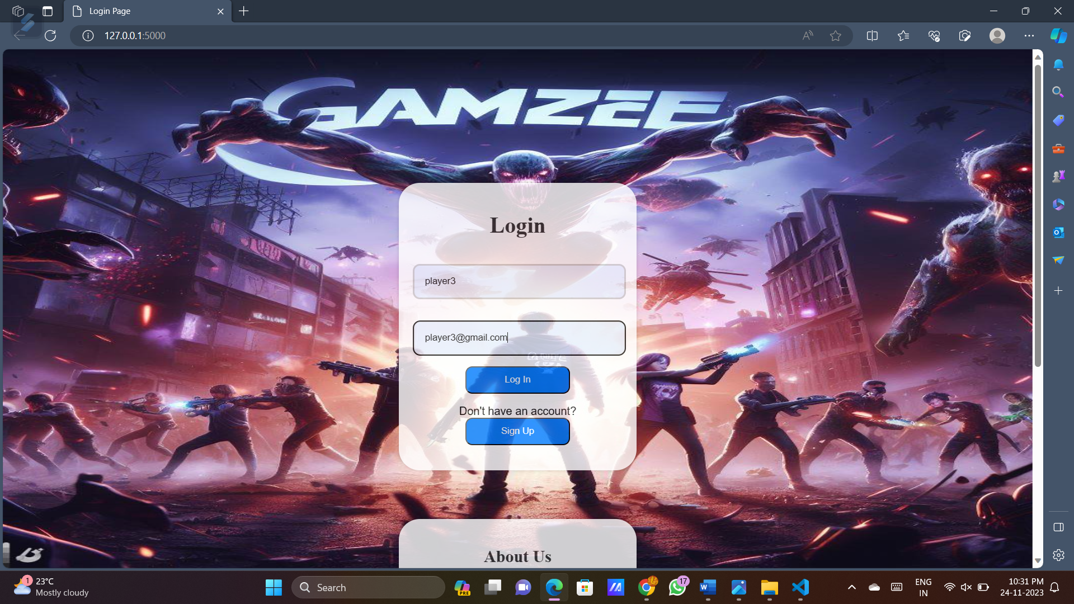 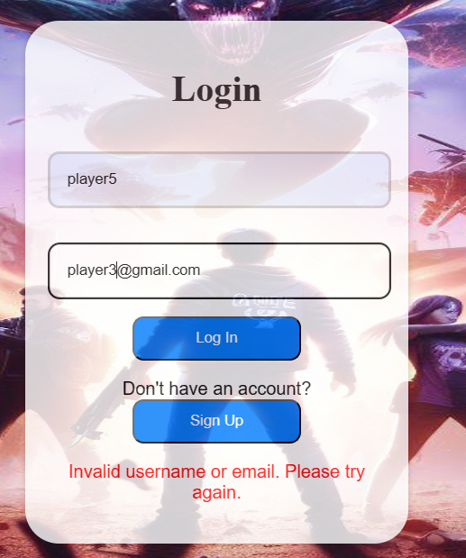

1).User login where it validates in the database.player table and then directs to main page only if the player exists in the table

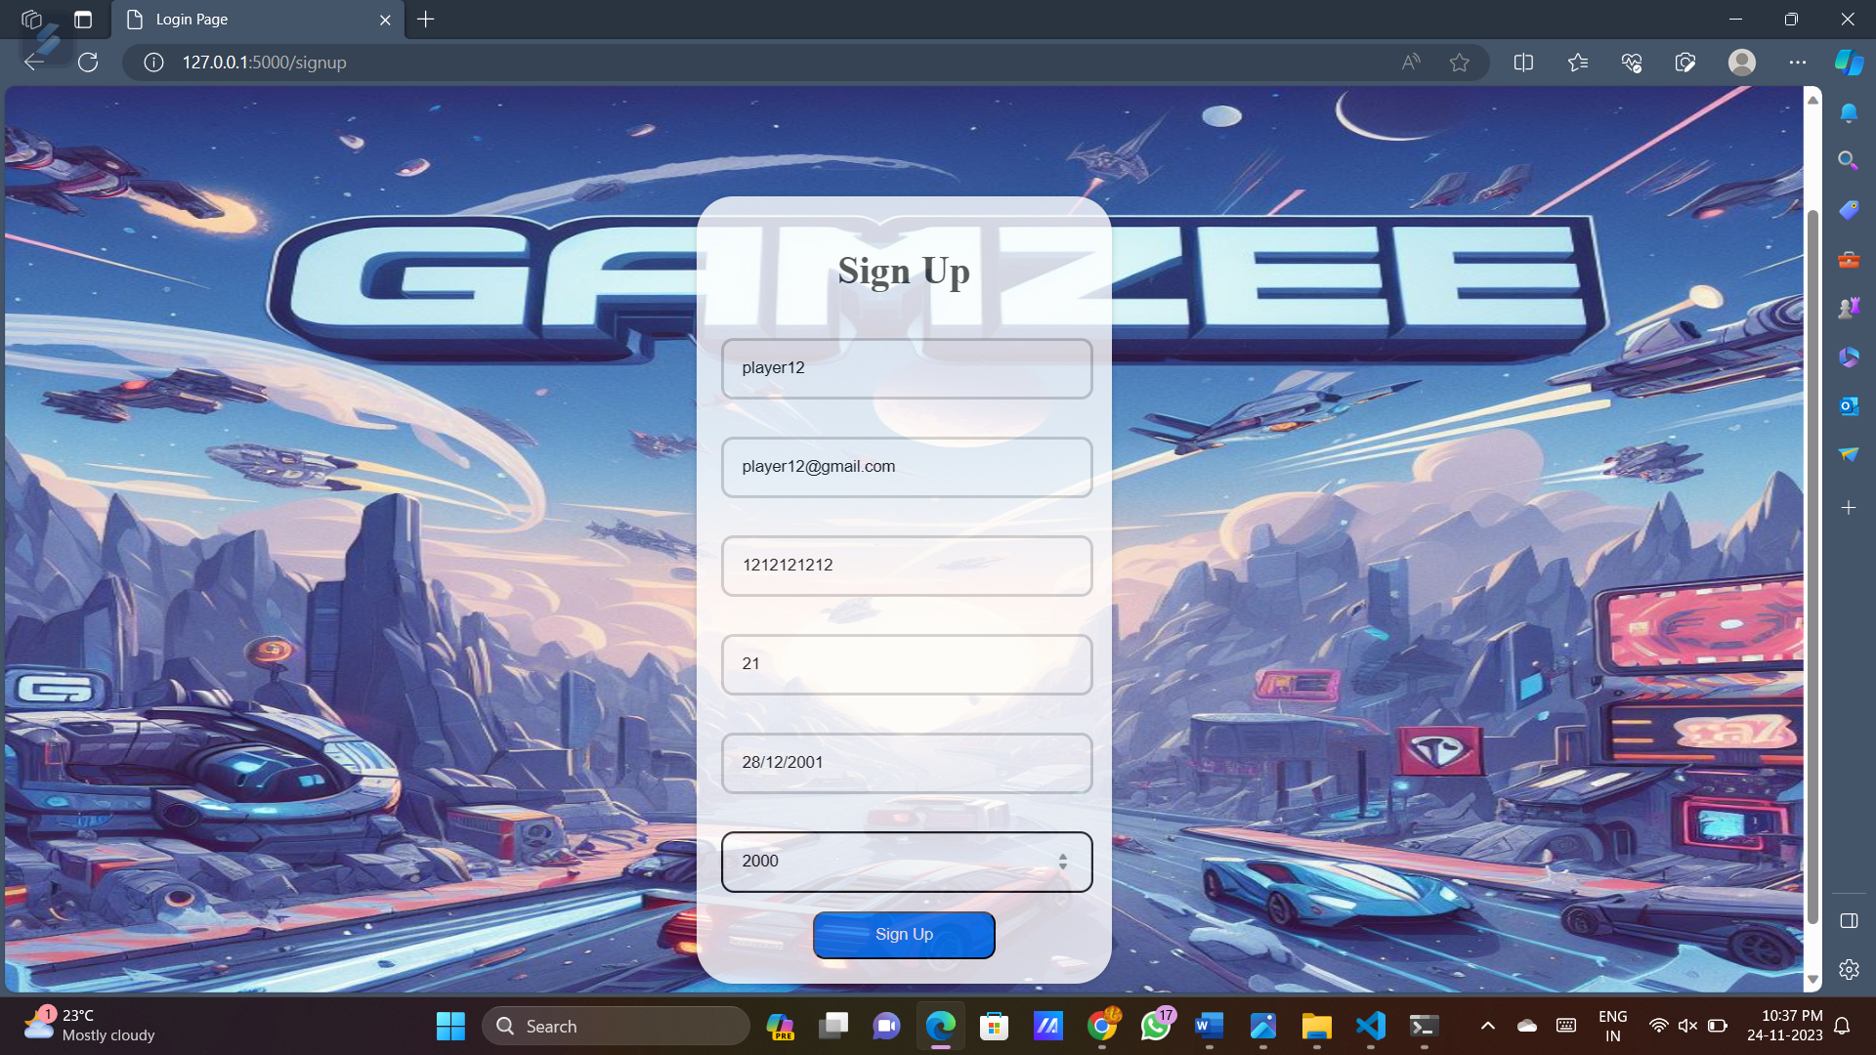

2).New player signing up hence adding a new player data into database.player table

3).Admin login on credentials validation

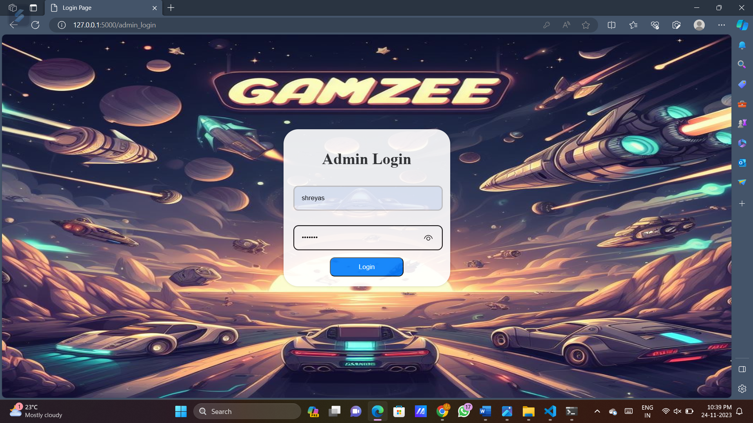

4).Admin dash board to create matches, tournaments, games, add developers and register teams.

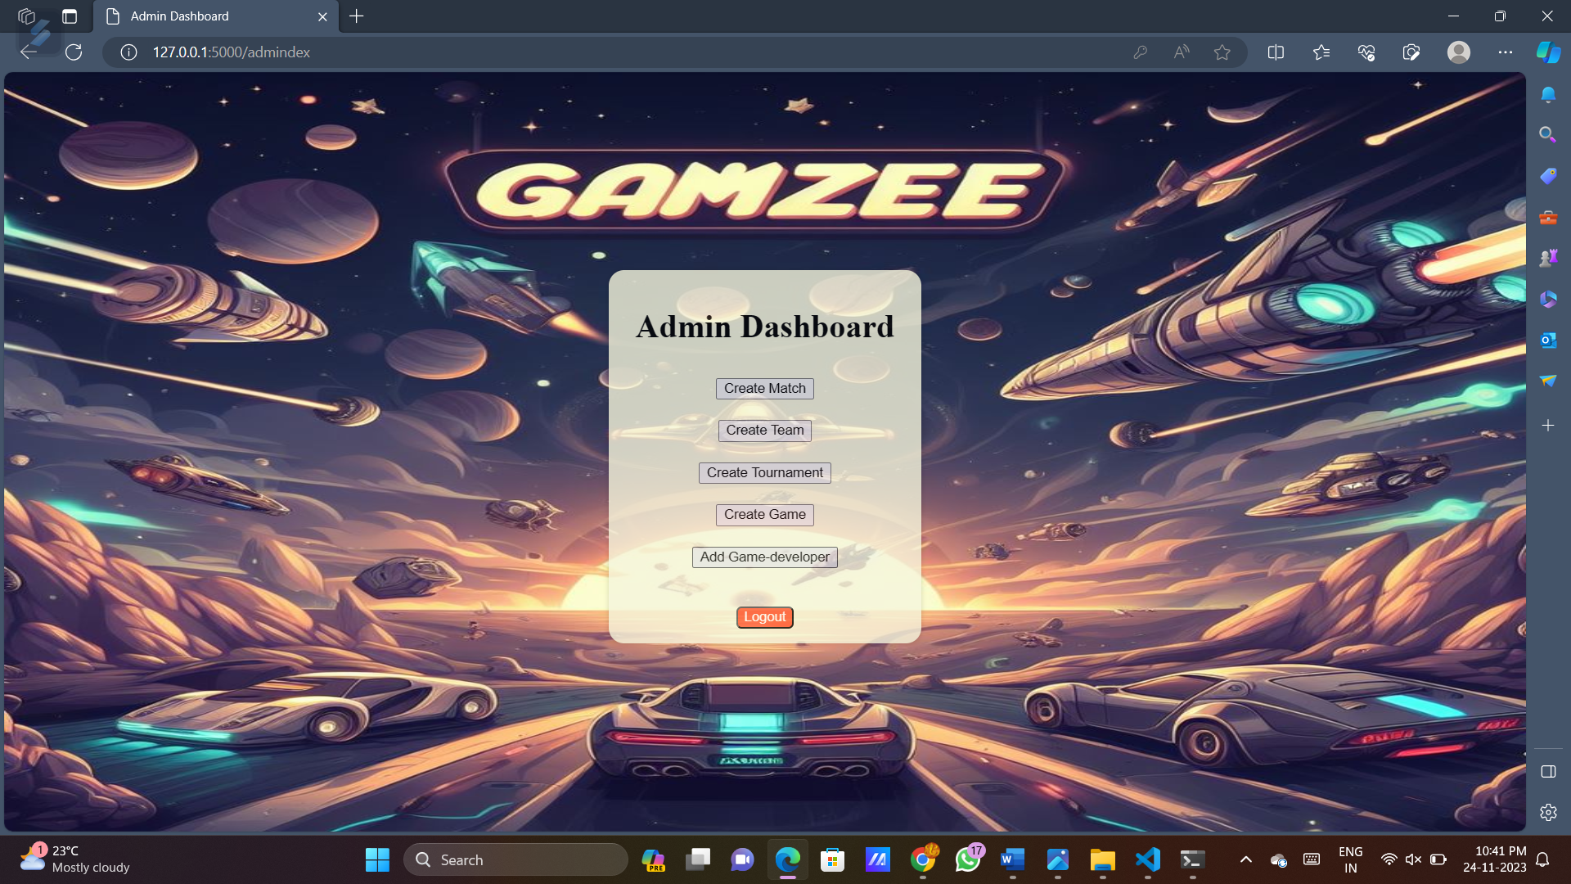

5).Admin adding new match to database.match table

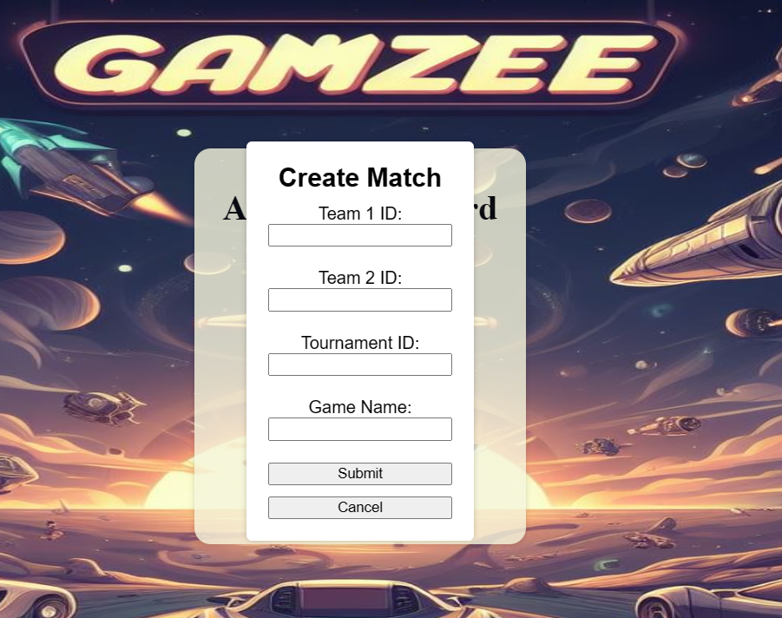

6).Admin registering new team i.e. adding new team into the database.team table

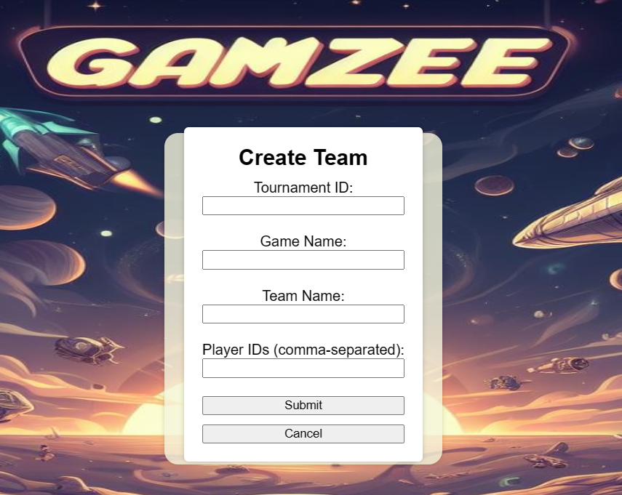

7).Admin organizing a new tournament i.e. adding new tournament data into database.tournament table

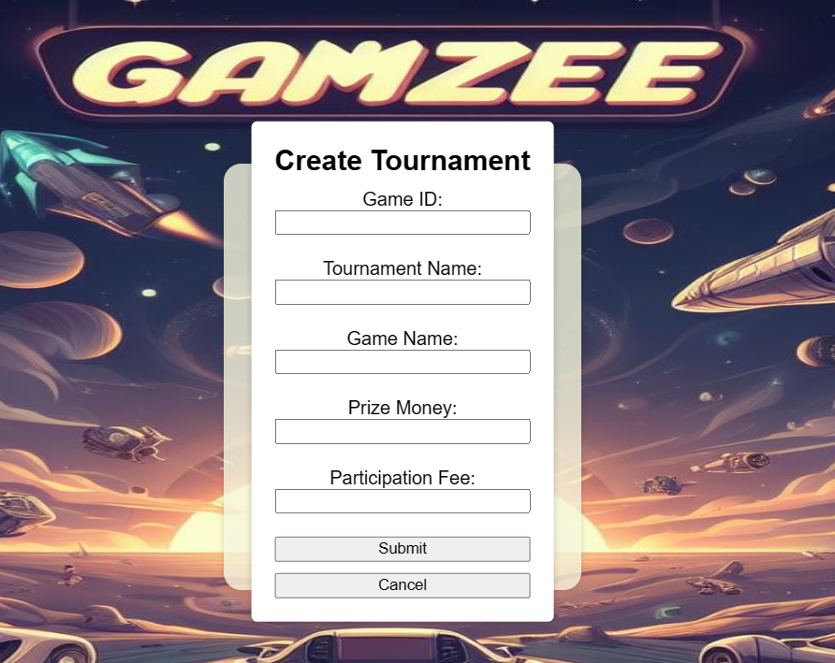

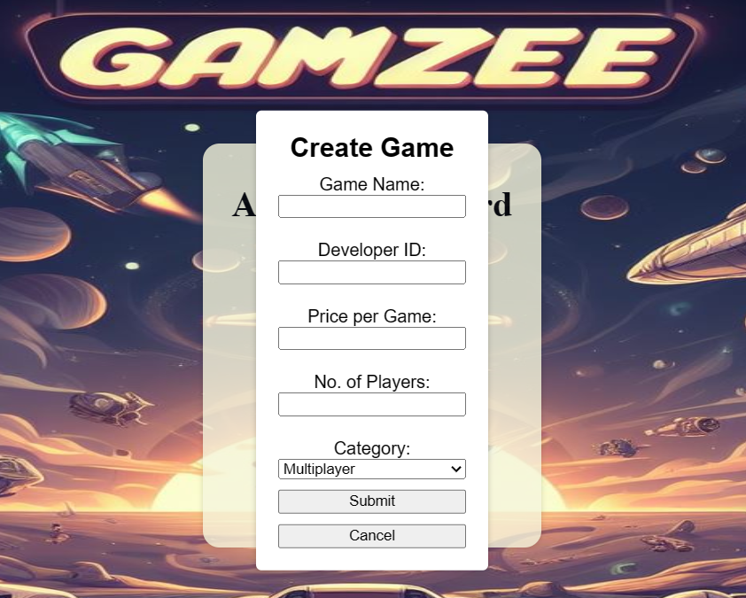 8).Admin adding new game into database.game table

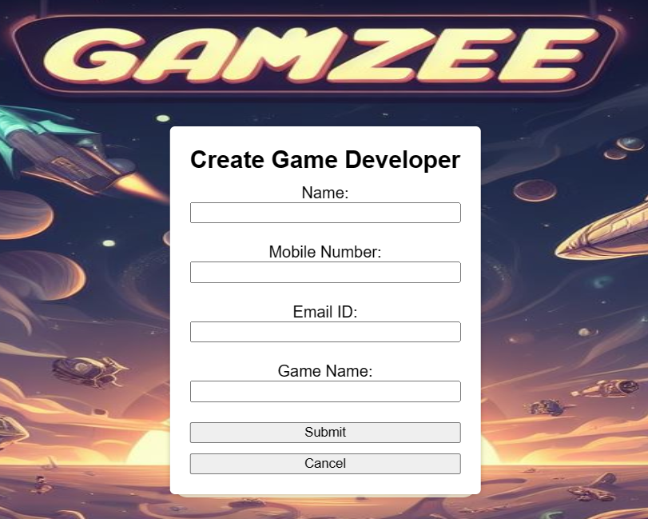9).Admin adding new game developer into database.

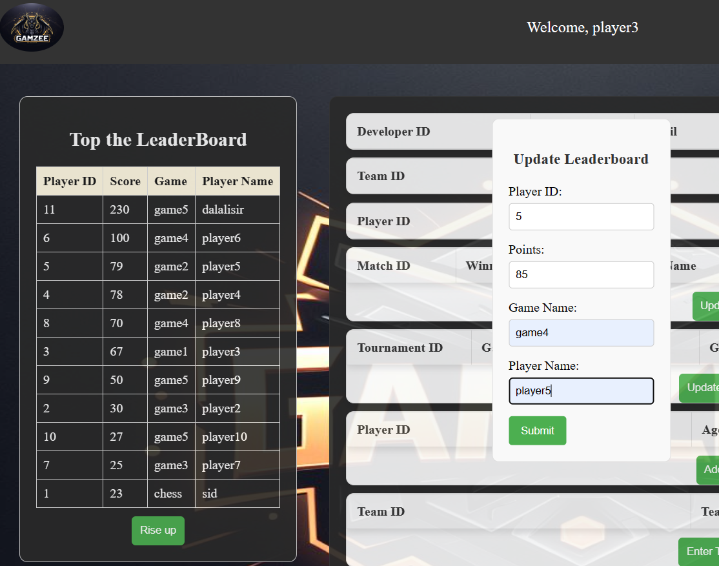

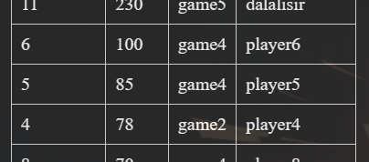

10).Updating leaderboard by player5 who topped in game4. On the click of **rise up** button, the update dialog box appears and on the click of **submit** button updates leaderboard.

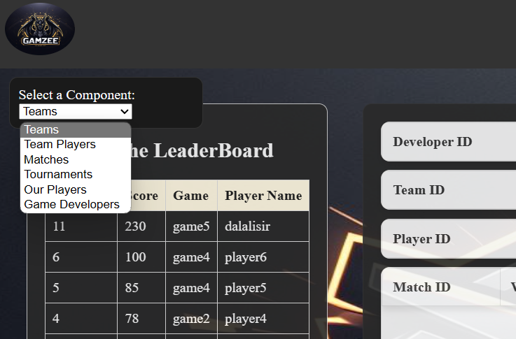

11).On selecting a particular option from the drop down box opens the respective table displaying tabular data by retrieving data from database.

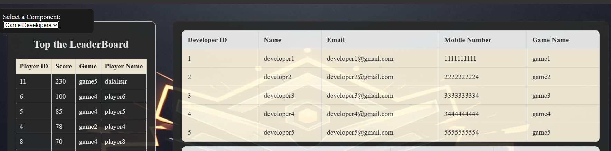

On selecting **Game Developers** option, displays developers details

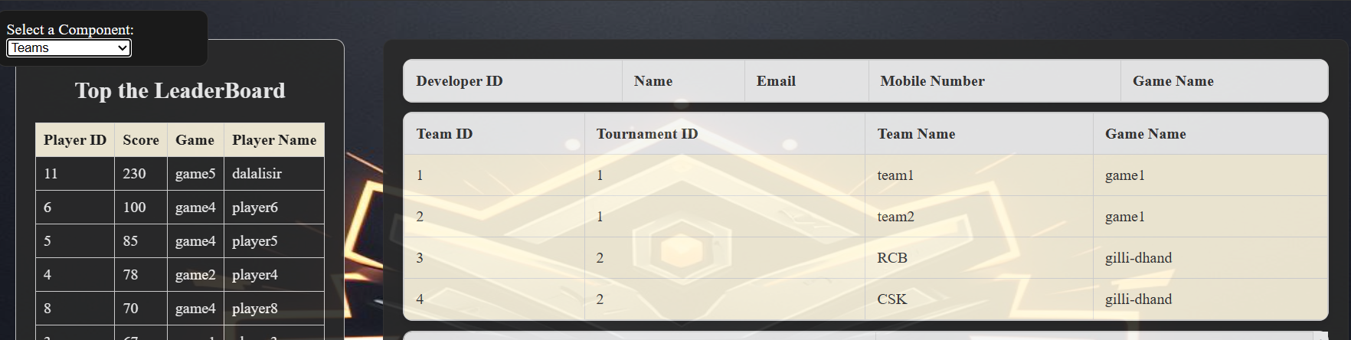

On selecting **Teams** option, displays teams details

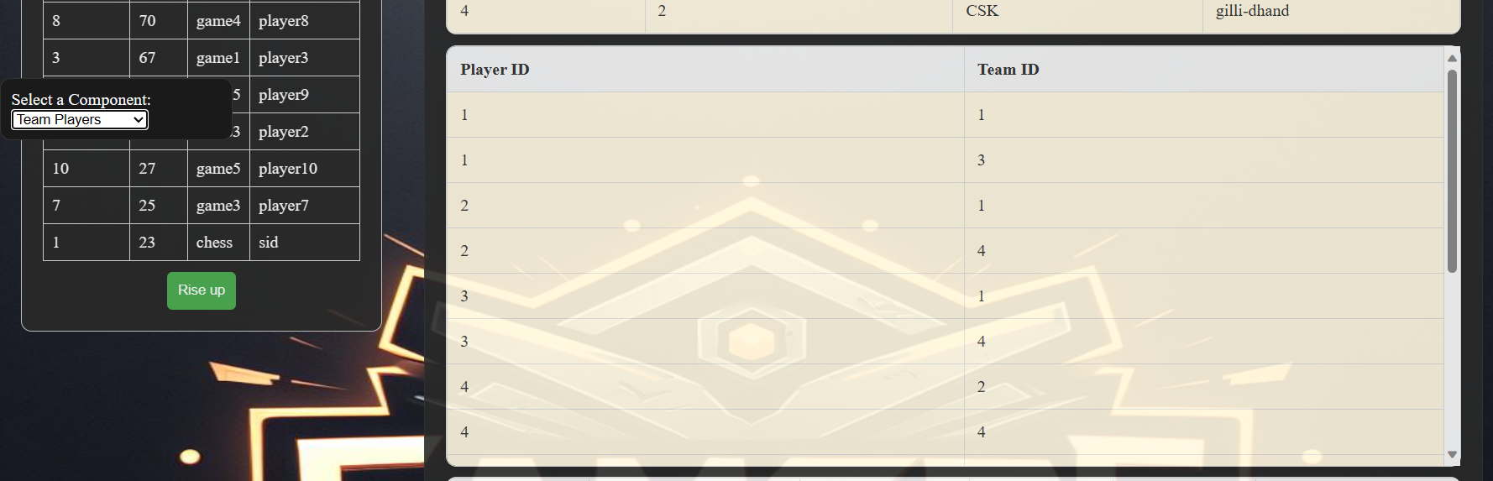

On selecting **TeamPlayers** option, displays team players and their respective teams.

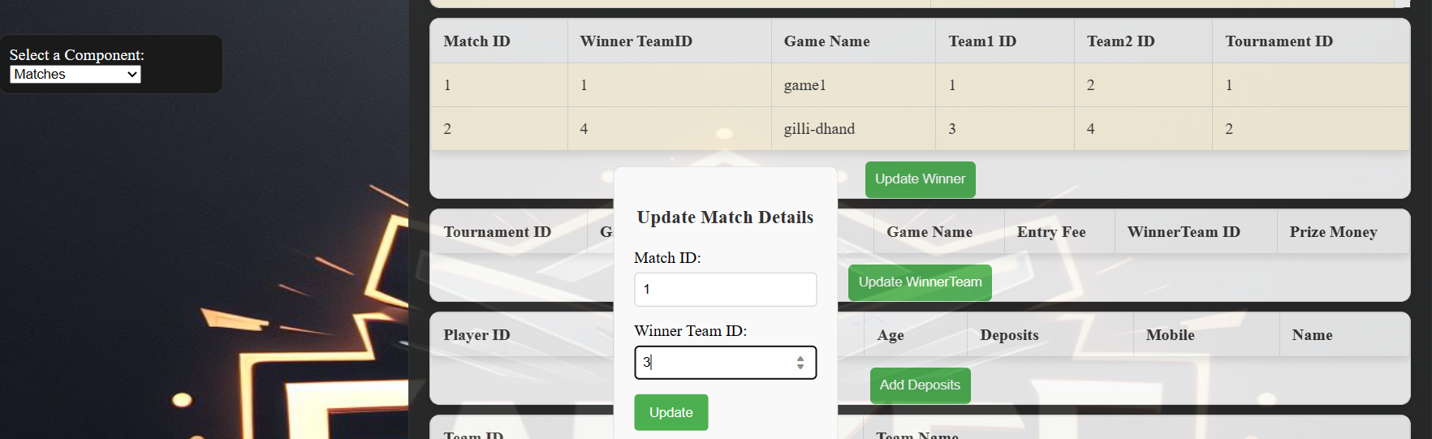

On selecting **Matches** option, displays the matches registered, on clicking **Update winner** button opens a dialog box asking for winner team ID updation.

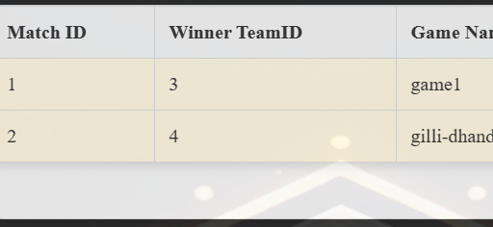

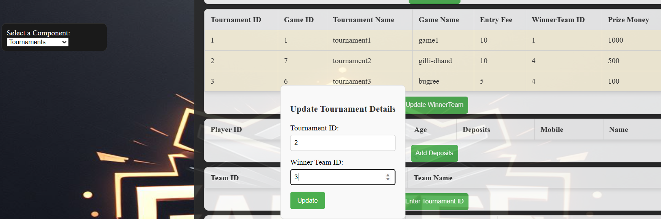

On selecting **Tournaments** option, displays the tournaments details, on clicking **Update winner** button opens a dialog box asking for winner team ID updation of that tournament.

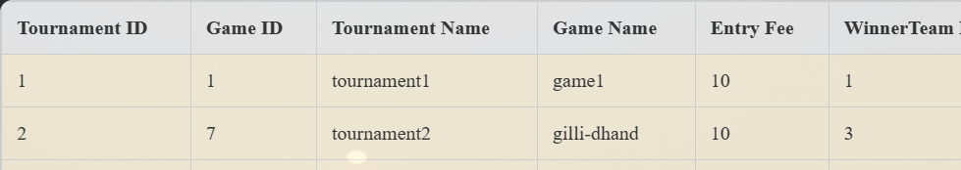

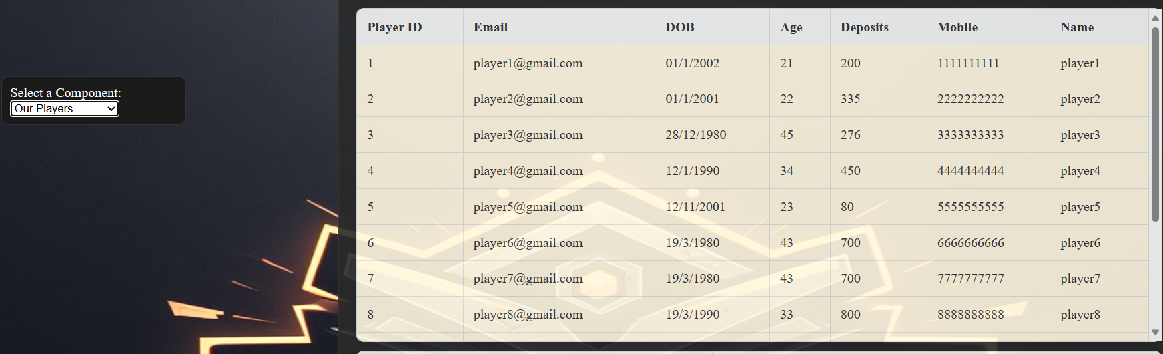

On selecting **Our Players** option, displays players details.

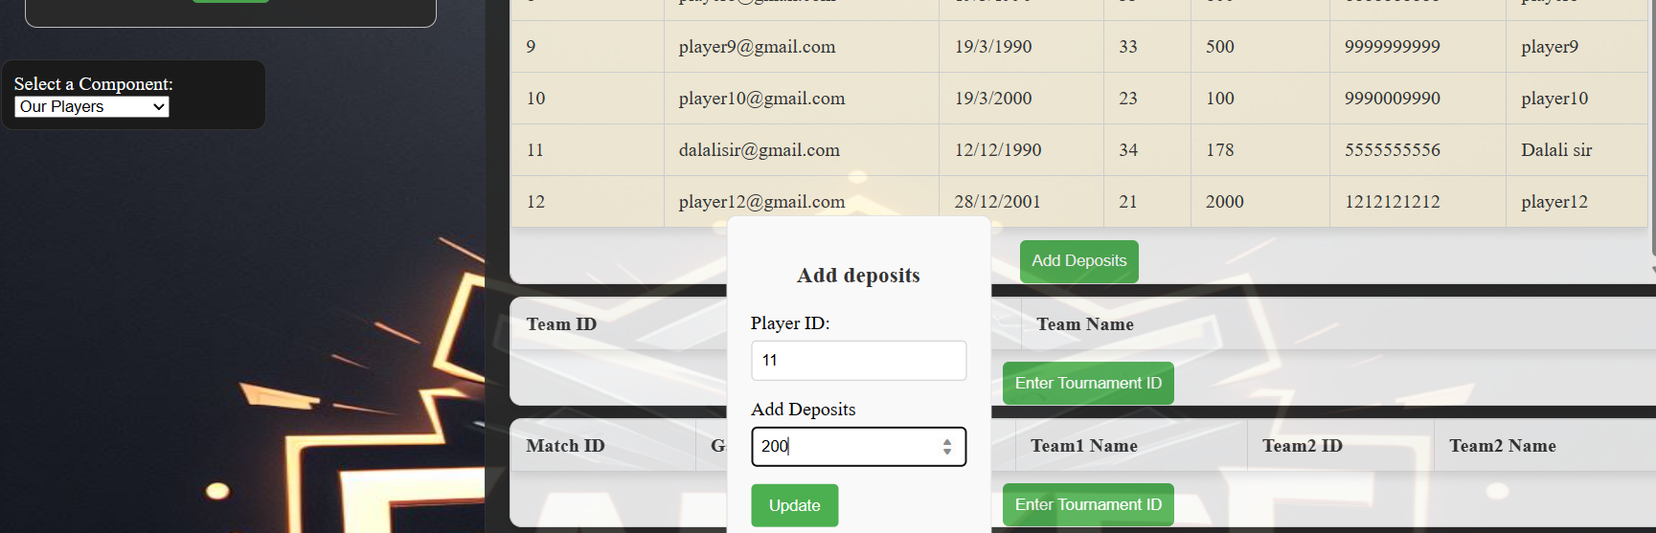

On clicking **Add Deposits**, opens a dialog box where a player can recharge his account and to credit amount to play games.

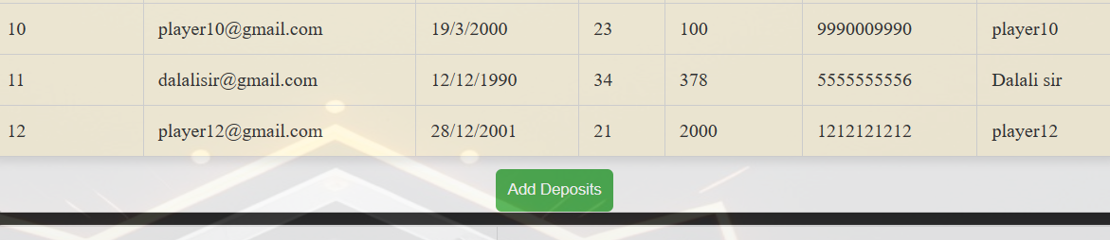

Enter tournament ID to know the teams playing in that team

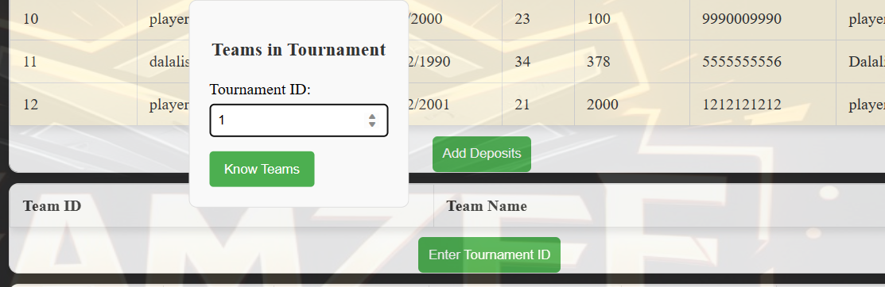

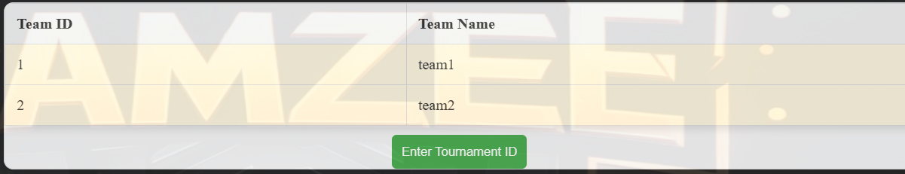

Enter tournament ID to know the matches being played in that tournament

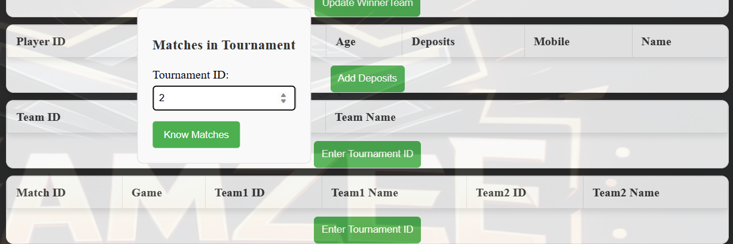

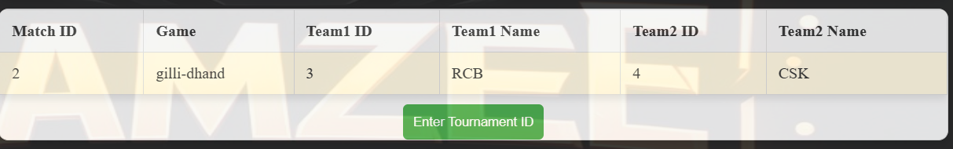

Enter Game ID to know the tournaments being organized on that particular game.

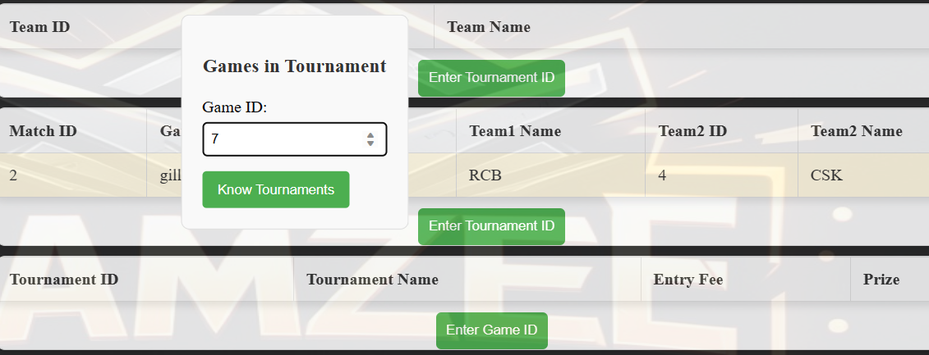

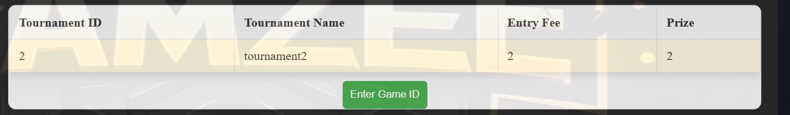

**Games Panel: -**

Games panel where player can play any of the game that he wishes to play from the game options displayed and once he chooses an game option on clicking play <game name> button, the fee for playing that game gets deducted from players deposits.

Here, now player3 chooses to game1 which charges 30 rupees for one game play and player3 has 276 in his deposits.



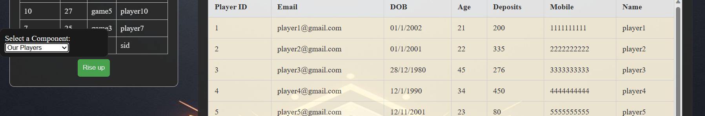

Once after playing game1, 30 rupees got deducted in player3 deposits.

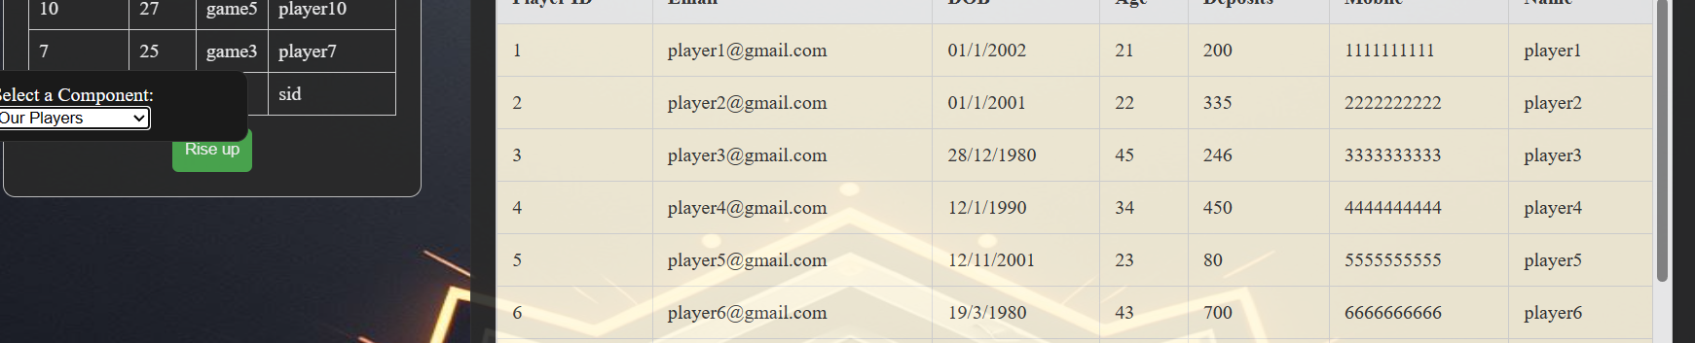

***Procedures being implemented: -***

DELIMITER //

CREATE PROCEDURE GetMatchDetailsByTournament(IN tourn_id_param INT)

BEGIN

    SELECT

        m.match_id,

        m.game_name,

        m.team1_id,

        t1.team_name AS team1_name,

        m.team2_id,

        t2.team_name AS team2_name

    FROM

        matches m

    INNER JOIN

        team t1 ON m.team1_id = t1.team_id

    INNER JOIN

        team t2 ON m.team2_id = t2.team_id

    WHERE

        m.tourn_id = tourn_id_param;

END //

DELIMITER ;

DELIMITER //

-----------------------------To get match details on entering tournament ID

DELIMITER //

CREATE PROCEDURE GetTopScorersPerGame()

BEGIN

    SELECT

        l.game_name,

        l.player_id,

        p.naame AS player_name,

        l.points

    FROM (

        SELECT

            game_name,

            player_id,

            points,

            RANK() OVER (PARTITION BY game_name ORDER BY points DESC) AS ranking

        FROM

            leaderboard

    ) l

    JOIN

        player p ON l.player_id = p.player_id

    WHERE

        l.ranking = 1;

END //

DELIMITER ;

DELIMITER //

-------------------To know about the Top scorers of all the games being played

DELIMITER //

CREATE PROCEDURE GetTeamsByTournament(IN tourn_id_param INT)

BEGIN

    SELECT

        t.team_id,

        t.team_name

    FROM

        team t

    WHERE

        t.tourn_id = tourn_id_param;

END //

DELIMITER ;

DELIMITER //

------------------To get Team details by entering tournament ID

DELIMITER //

CREATE TRIGGER UpdatePlayerDeposits

AFTER INSERT ON games_played

FOR EACH ROW

BEGIN

    DECLARE game_ppm INT;

    -- Get the ppm value of the game

    SELECT ppm INTO game_ppm

    FROM game

    WHERE game_id = NEW.game_id;

    -- Update player's deposits based on ppm value

    UPDATE player

    SET deposits = deposits - game_ppm

    WHERE player_id = NEW.player_id;

END //

Trigger set to update player deposits once after playing player finishes playing a particular game.

***Query operations in Backend flask application: -***

*Validation of player Login credentials.*

user = Player.query.filter_by(naame=username, mail_id=email).first()

Dynamic Adding of new player data

 new_player = Player(

            mail_id=email,

            dob=dob,

            age=age,

            deposits=deposits,

            mobile=mobile,

            naame=username

        )

        db.session.add(new_player)

        db.session.commit()

To make out leaderboard data

 leaderboard_data = []

    leaderboard_data_query = text("SELECT player_id, points, game_name, player_name FROM leaderboard ORDER BY points DESC")

# Check if the entry already exists in the leaderboard

        existing_entry = Leaderboard.query.filter_by(player_id=player_id).first()

        if existing_entry:

            # Update the existing entry

            existing_entry.points = points

            existing_entry.game_name = game_name

            existing_entry.player_name = player_name

        else:

            # Create a new entry in the leaderboard

            new_entry = Leaderboard(player_id=player_id, points=points, game_name=game_name, player_name=player_name)

            db.session.add(new_entry)

Data retrievals query: -

developers_data = Developer.query.all()

 matches_data = Matches.query.all()

Query to update winner team in match being played: -

def update_matches():

    if request.method == 'POST':

        match_id = request.form.get('match_id')

        wint_id = request.form.get('wint_id')

        # Check if the entry already exists in the leaderboard

        existing_entry = Matches.query.filter_by(match_id=match_id).first()

        if existing_entry:

            # Update the existing entry

            existing_entry.wint_id = wint_id

        else:

           pass

        # Commit changes to the database

        db.session.commit()

        # Check if the entry already exists in the leaderboard

        existing_entry = Player.query.filter_by(player_id=player_id).first()

        if existing_entry:

            # Update the existing entry

            existing_entry.deposits = int(existing_entry.deposits) + int(deposits)

        else:

           pass

Query to retrieve tournaments data based on game ID

if request.method == 'POST':

        # Get the game_id from the query parameters

        tg_id = request.form.get('tgid')

        # Check if tg_id is not None before converting to an integer

        if tg_id is not None:

            tg_id = int(tg_id)

            # Query the tournaments for the given game_id

            tournaments_data = Tournament.query.filter_by(game_id=tg_id).all()

            rows = []

            for tg in tournaments_data:

                row = f'<tr><td>{tg.tourn_id}</td><td>{tg.tourn_name}</td><td>{tg.tourn_id}</td><td>{tg.tourn_id}</td></tr>'

                rows.append(row)